Current Electoral Area Official Community Plan (OCP) Bylaw No. 2458, 2008 | Proposed Electoral Area Official Community Plan (OCP) Bylaw No.3010, 2023 (using draft 2023-04-03)
3.0 COMMUNITY PROFILE  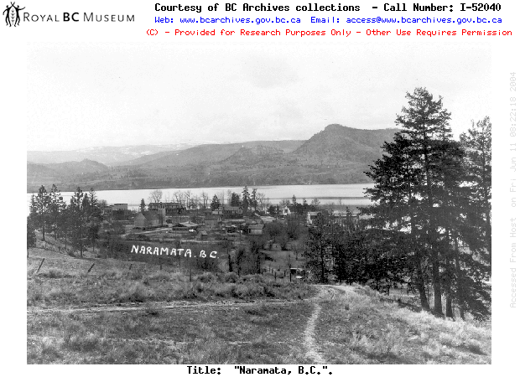  3.1 Historical Context  Naramata circa 1925  Source: BC Archives  This unique area of British Columbia’s southern interior has long been considered a desirable location for people to live. The original people of the Okanagan known as the syilx speaking people recognized this, as they have lived and worked on this land long before the arrival of the Europeans. In 1907, John Moore Robinson recognized the many locational advantages of Naramata including its proximity to Okanagan Lake, the ideal climate, unique town site, and fertile agricultural land.  John Robinson thought Naramata an ideal settlement site, where he established a development company known as the Okanagan Trust Company Limited. The Okanagan Trust Company soon surveyed the town, orchard tracts and roads, created an irrigation system, in addition to building various local services, such as a school and a post office in order to the promote the Village of Naramata. In 1907 Robinson’s Okanagan Trust Company Limited surveyed approximately 600 acres into enticing 2, 5, and 10 acre orchard tracts, attracting settlers from across North America and Britain. The three families that largely settled Naramata’s original orchard lots included the Roes, the Partridges and the Littlejohn family.  Eventually, several packing houses were built, including, the Naramata Fruit Company and E. Mallory and Okanagan Packers to accommodate the increasing amount of fruit being produced in the area. Initial transportation networks to Naramata consisted of a ‘horse and buggy’ trail from Penticton and the ferry from Summerland. In 1908, a government wharf was constructed, which allowed for larger paddle-wheel steamers to dock, and the frequency of trips and expansion of the ferry fleet soon followed with the incorporation of the Okanagan Lake Boat Company, later purchased by the Naramata Syndicate.  The construction of the Kettle Valley Railway also significantly impacted what is now called Electoral Area “E”, bringing both workers and settlers to the general area. In the mid 20th Century the Christian Leadership Training School, now known as the Naramata Centre was established, and for over 55 years the Naramata Centre has attracted people from around the world who are seeking continued education often related to healing, learning, empowerment and spiritual renewal.  Also of significance, in the 1980s local grape growers lobbied Provincial politicians to allow for small winery operations to sell and produce their wines to the public. In 1989, local winemakers were successful in convincing the Province to create ‘Farm-gate Winery’ licenses, effectively opening the door to numerous small growers on the Naramata Benchlands. Lang Vineyards was the first in rural Naramata to receive this type of winery license and opened its wine operation in 1990, and the growth of the local wine industry soon followed. As a result, the increasing density and land uses now occurring within the rural urban interface and agricultural land uses throughout the entire Okanagan Valley can frequently trace their origin to some of the factors that initially caused people to settle within the region. | 3.0 COMMUNITY PROFILE  3.1 Location and Geography  Covering 545 square kilometres, Electoral Area “E” is located in the Regional District of Okanagan-Similkameen (RDOS) and is bounded by Okanagan Lake to the west, the City of Penticton to the south, and Okanagan Mountain Provincial Park to the north. Electoral Area “E” also comprises the unincorporated community of Naramata.  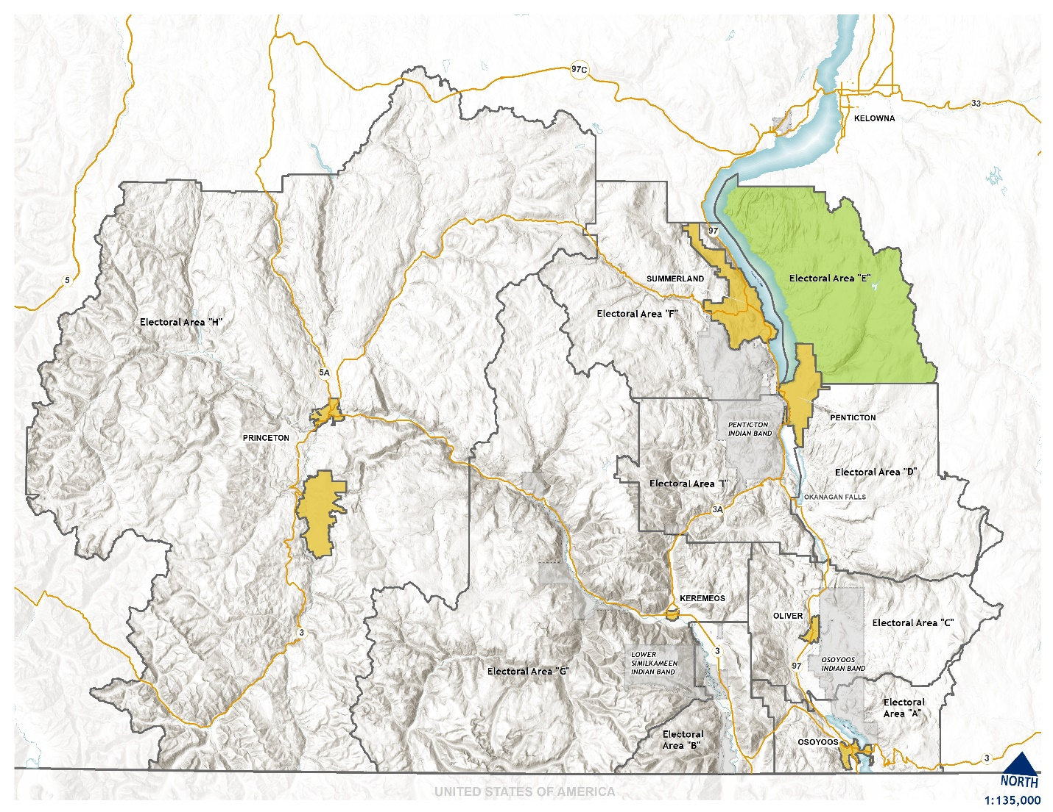Figure 1: Plan Area Regional Context
3.2 History
Indigenous people have lived in the RDOS area for thousands of years prior to the arrival of Europeans. The original people of the Okanagan are known as the syilx speaking people – the “Okanagans” and according to their history have been in the area since the beginning of people on this land. The Okanagans (syilx) people occupied an area that extended over approximately 69,000 square kilometres. The northern area of this territory stretched from the area of Mica Creek, just north of modern-day Revelstoke, BC and east to Kootenay Lake. The southern boundary extended to the vicinity of Wilbur, Washington and the western border extended into the Nicola Valley.
Okanagan First Nations once travelled widely to fishing, gathering and hunting areas. Each year, the first harvests of roots, berries, fish and game were celebrated by ceremonies honouring the food chiefs who provided for the people. During the winter, people returned to permanent winter villages and the names of many of the settlements in the Okanagan Valley – Osoyoos, Keremeos, Penticton and Kelowna – all come from Indigenous words for these settled areas and attest to the long history of the syilx people on this land.
The non-Indigenous historical records of the plan area date back to 1821 with establishment of the Hudson’s Bay Fur Brigade Trail. The Trail represented a fur trading supply route through the Okanagan Valley north to Kamloops. With the United States and Canada boundary settlement in 1847, alternative trails were developed from Kamloops through the Fraser Canyon to Fort Langley. The last brigade took the trail in 1847.
In 1907, John Moore Robinson recognized the many locational advantages of Naramata including its proximity to Okanagan Lake, the ideal climate, unique town site, and fertile agricultural land.
John Robinson thought Naramata an ideal settlement site, where he established a development company known as the Okanagan Trust Company Limited. The Okanagan Trust Company soon surveyed the town, orchard tracts and roads, created an irrigation system, in addition to building various local services, such as a school and a post office in order to the promote the Village of Naramata. In 1907 Robinson’s Okanagan Trust Company Limited surveyed approximately 600 acres into enticing 2, 5, and 10 acre orchard tracts, attracting settlers from across North America and Britain. The three families that largely settled Naramata’s original orchard lots included the Roes, the Partridges and the Littlejohn family.
There are several theories as to how the name ‘Naramata’ was derived. One of the most popular theories dates from 1907, not long after the founding of the community by John Moore Robinson. The story is told that a séance was held in the tent house of Mrs. Gillespie, Mr. Gillespie being a business associate of Robinson. Mrs. Robinson, acting as a medium, channeled the voice of a Sioux Chief named Big Moose. The Chief spoke of his love for his wife Narramattah; she was the “Smile of Manitou”.
In 1914, Naramata received a new link with the rest of Canada when the Kettle Valley Railway was completed on the hillside above the village. The railway operated until 1974.

3.3 Communities and Settlement Areas
Electoral Area “E” is largely rural area with Crown land comprising approximately 67%, or two thirds, of the land base. Residential development has primarily occurred on the benches overlooking Okanagan Lake with residential development primarily occurring within the Naramata village area and on the hillsides between the Agricultural Land Reserve (ALR) boundary and the former Kettle Valley Railway (KVR) right-of-way. Other settlement areas include Falcon Ridge and the Indian Rock Road areas.

3.4 Penticton Indian Band
The Penticton Indian Band (PIB), who are based in a part of syilx traditional territory known as snpink’tn, is one of the eight communities in the Okanagan Nation, along with the Upper Similkameen, Lower Similkameen, Osoyoos Indian Band, Westbank Indian Band, Okanagan Indian Band, Colville Confederated Tribes and Upper Nicola Indian Band.
Electoral Area “E” is comprised of unceded syilx territory and is protected and managed by PIB. The entire area contains important traditional territory for harvest and ceremony as well as historic sites that need to be maintained and protected.
Given the community’s deep connection to the land, PIB was hired to complete an assessment of the lands in Electoral Area “E” to inform this Official Community Plan. The assessment itself, titled TL NPƏNYAʕTNITKʷ UŁ TANʔ YAʕCISCUT, which can be interpreted as From the mouth of Ellis Creek Canyon to Chute Lake: PIB AREA E OCP ASSESSMENT, is confidential due to the importance of keeping traditional sites safe (for example, important cultural sites have been destroyed in the past once their location was revealed), but several key points have been summarized below.
The Penticton Indian Band (PIB), who are based in a part of syilx traditional territory known as snpink’tn, is one of the eight communities in the Okanagan Nation, along with the Upper Similkameen, Lower Similkameen, Osoyoos Indian Band, Westbank Indian Band, Okanagan Indian Band, Colville Confederated Tribes and Upper Nicola Indian Band.
Electoral Area “E” is comprised of unceded syilx territory and is protected and managed by PIB. The entire area contains important traditional territory for harvest and ceremony as well as historic sites that need to be maintained and protected.
Given the community’s deep connection to the land, PIB was hired to complete an assessment of the lands in Electoral Area “E” to inform this Official Community Plan. The assessment itself, titled TL NPƏNYAʕTNITKʷ UŁ TANʔ YAʕCISCUT, which can be interpreted as From the mouth of Ellis Creek Canyon to Chute Lake: PIB AREA E OCP ASSESSMENT, was completed in 2021, and is confidential due to the importance of keeping traditional sites safe (for example, important cultural sites have been destroyed in the past once their location was revealed). Key aspects of this assessment, such as cultural history, context, important plants and animals have been included below:
This PIB assessment provides a syilx perspective of the ecological, biologically diverse and cultural values that weave nʔxʷəlxʷəltantət (that which keeps us alive) together within the region known as RDOS Area E. Area E is located in a part of syilx Territory that has been utilized and taken care of by the syilx people for many thousands of years. Activities in this area have impacted and will continue to impact our tmxʷulaxʷ (land), siwɬkʷ (water) and tmixʷ (all living things) within a broad and critically important part of syilx Territory.
It is important for those reading to understand how the syilx life-way views siwɬkʷ and tmixʷ. siwɬkʷ and tmixʷ are our relatives, no different from a sister or brother, mother or father. We do not view impacts to our siwɬkʷ and tmixʷ as a tolerable activity. When you hurt our siwɬkʷ you are hurting our relative, a relative who has sustained us since the beginning of time. A relative who we owe respect and reciprocity; a relative who teaches us and helps us to live in a good way for the good of all. When you hurt our tmixʷ you are hurting those who laid their life down for us, who shared their bodies and their knowledge so that our people might survive. All living things have a spirit and are a part of us; within our Territory we are responsible for their health and wellbeing. Needlessly killing or harming our relatives to support an ever-increasing population which, in turn, will lead to ever increasing impacts to our siwɬkʷ and tmixʷ is not acceptable.
It is abundantly clear that unilaterally developed provincial, regional and municipal land use standards completely ignore the syilx worldview and perspective; they cannot be relied upon to ensure for the protection of syilx values and upholding syilx laws and caretakership responsibilities. The syilx life-view, and this assessment, are based on an amalgamation of considerations that include syilx culture, lifestyle, values, teachings, laws and oral history that include the obvious: all things on the land in any given area are interconnected and interdependent. Therefore, any alterations to the land or the systems upon it are affected exponentially and cumulatively by the myriad of lasting changes from both a cultural and environmental perspective that come from developments in the OCP subject area.
The assessment provides information on important edible and medicinal plants that have been identified throughout Electoral Area “E”. These plants include, but not limited to, species such as Frogleaf, Stonecrop, Thistle, Stinging Nettle, Choke cherry, Chocolate lily, Lichen, Alder, Saskatoon, Soapberry and Devils Club.
Electoral Area “E” has been a critical hunting and harvesting area for thousands of years. There are numerous captik^{w}ɬ (sacred texts, stories and oral traditions) which speak to hunting camps, village sites, camping areas, travel corridors and unique hunting techniques and tools associated with this area. Examples of animals that remain important include, but not limited to: Deer, Bear, Moose, Mountain goat, Grouse, reptiles and amphibians.
It is difficult to help anyone understand how our people feel about the impact to our cultural markers, pictographs, ceremonial use areas and way of life. These cultural works and place-markers are a part of who we are. Our history here is deep rooted and proven for thousands of years. To impact our history, our culture, our way of life is not right. Our syilx people have used this entire area for fasting, rites of passage, family campgrounds, harvesting and living since time immemorial.
The syilx worldview, syilx principles, protocols and practices have taken care of all lands and waters within the syilx Territory for many thousands of years. We know how to take care of our lands. By working together PIB and the RDOS can ensure that development is sustainable, land use is appropriate and tmix^{w} survive and thrive for the good of all, for alltime.
TL NPƏNYAʕTNITKʷ UŁ TANʔ YAʕCISCUT , PIB Area E OCP Assessment Report, 2022

3.5 Population and Demographics
The total population of the Electoral Area “E” area is 2,015 people, which is an increase of only 19 residents between 2001 and 2021. This represents an annual average growth rate of approximately 0.05%, or 0.95% over the 20-year period. Of note; however, between 2016 and 2021 there was a 5.9% population increase, equating to 112 new residents.
Of the nine electoral areas that comprise the RDOS, eight grew in population between 2001 and 2021 while only Electoral Area “C” experienced a decline. Electoral Area “E” experienced the smallest growth during this time. In comparison, the population of the RDOS — which includes the member municipalities of Penticton, Summerland, Oliver, Osoyoos, Keremeos and Princeton — grew by over 17% in this same period (Figure 3).
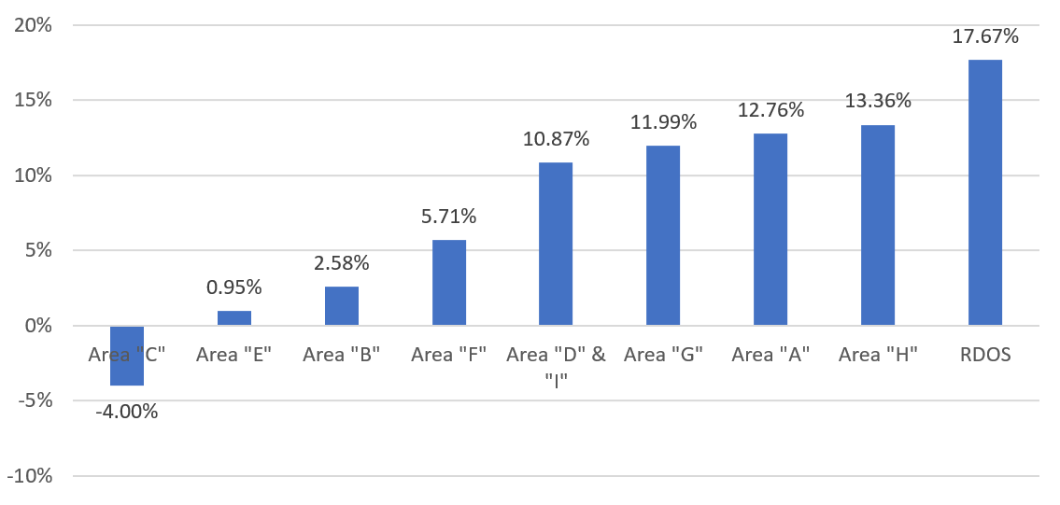
Figure 2: Regional Growth Rate Comparisons 2001-2021

The age and gender distribution of the historic Electoral Area “E” is illustrated in Figure 4. Overall, approximately 51% of the population is female and 49% male. In Electoral Area “E”, the “baby boomer” generation (currently aged 55-75 years old) makes up the largest proportion of the population (46% of the population in 2021). In comparison, the 20-34 age group comprised only 9% of the population in the 2021 census. The profile shown in Figure 4 provides a strong contrast to the Province of BC, which is shown in Figure 5. Both show an aging population; however, the proportion of residents aged 20-34 years in Electoral Area “E” is low relative to the Province (20%).
Electoral Area “E” has a significantly higher proportion of older residents in proportion to youth and young adults. In 2021, the median age in Electoral Area “E” was 59 years, while the provincial median age was 43 years – a difference of 16 years. The median age for Electoral Area “E” was also higher than that of the RDOS where the median age in 2021 was 56 years.

Figure 3: Electoral Area “E” Population by Gender and Age Cohort (2021)

Figure 4: BC Population by Gender and Age Cohort (2021)

Total population figures from 1996 to 2021 suggest a population that has been largely consistent (Figure 6). If modest population growth or decline were to continue for the next 20 years, the population could be expected to be between 1,822 and 2,460 by 2041, given scenarios of +1% growth, +0.5% growth or -0.5% decline.

Figure 5: Electoral Area “E” Projected Population Growth (1996-2041)

3.6 Housing types
The overwhelming majority of housing in Electoral Area “E” consists of single-detached homes (Figure 6). The remaining housing forms are mobile homes, duplex/semi-detached housing, and apartment units with fewer than five stories. Generally, the housing in Electoral Area “E” is relatively low-density and dispersed.

Figure 6: Housing by Dwelling Type in Electoral Area “E” (2021)

Most households (52.8%) in Electoral Area “E” are two person households (Figure 8). Together, one and two person households account for 75.3% of households. These smaller household sizes are consistent with the older population in the planning area.

Figure 7: Electoral Area “E” Household Size (2021)

