Current Electoral Area Official Community Plan (OCP) Bylaw No. 2458, 2008 | Proposed Electoral Area Official Community Plan (OCP) Bylaw No. 3010, 2023 (using version 2023-06-01)
15.0 AGGREGATE AND MINERAL RESOURCES  15.1 Background  The Regional District has limited influence on the location of mineral and aggregate resource extraction. The objectives and policies of this section remain broad in nature to offer guidance to senior governments in their decision-making process. Figure XX illustrates potential aggregate areas in the Plan Area (i.e., where aggregate resources are located, not that they should be extracted wherever they are located). | 20.0 AGGREGATE AND MINERAL RESOURCES  20.1 Background  The Regional District has limited influence on the extraction of mineral and aggregate resources. The objectives and policies of this section remain broad in nature to offer guidance to senior governments in their decision-making process. Figure 24 illustrates potential aggregate extraction areas in the Plan Area and existing aggregate operations.  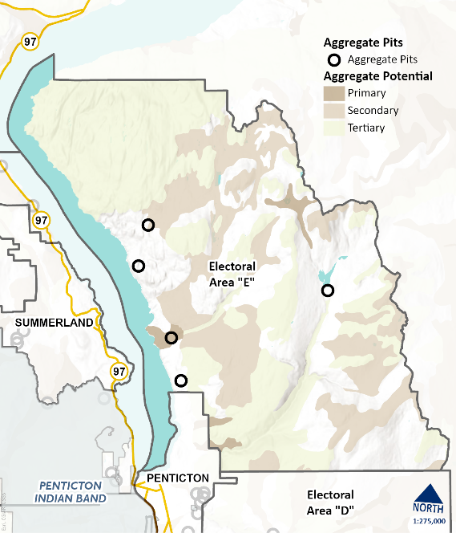
15.2 Objectives  - Protect sand and gravel aggregate supplies for anticipated future needs.  - Protect non-agricultural lands having recoverable aggregate or mineral resources from development or adjacent uses that would limit or prohibit extraction.  - Minimize conflicts between sand and gravel processing operations and adjacent land uses.  - Support the Province to require rehabilitation and remediation of resource extraction sites.  - Direct sand and gravel extraction proposals toward sites that have no adverse environmental impact or where the impact can be adequately mitigated. | 20.2 Objectives  - Protect sand and gravel aggregate supplies for anticipated future needs.  - Protect non-agricultural lands with recoverable aggregate or mineral resources from development or adjacent uses that would limit or prohibit extraction.  - Minimize conflicts between sand and gravel processing operations and adjacent land uses.  - Support the Province to require rehabilitation and remediation of resource extraction sites.  - Direct sand and gravel extraction proposals toward sites that have no significant adverse environmental impact or where the impact can be adequately mitigated.
15.3 Policies  The Regional Board:  Encourages the Province to continue referrals of mineral exploration proposals to the Regional District for comment and due consideration of the impact of resource extraction activities on surrounding land uses and development.  .2 Supports the use of designated Resource Areas for sand and gravel extraction, where the uses will not cause a significant visual or environmental disturbance.  .3 Will consider rezoning applications for the processing of aggregate resources based on any or all of the following criteria:  - extent of visual screening, and other mitigation works proposed;  - type of processing proposed;  - prevailing wind direction, and the potential for noise and dust;  - compatibility with adjacent land uses;  - environmental sensitivity of the site, and lands adjacent to potential aggregate resource processing site;  - accessibility; and  - characteristics of aggregate deposits and groundwater resources.  .4 Encourages the Province not to issue new surface leases and permits for mineral processing within 1,000 metres of designated residential areas unless effective mitigation measures can be implemented to significantly reduce or nullify the effects of the proposed activity.  .5 Encourages the Province not to issue leases or permits for aggregate or mineral extraction or processing.  .6 Encourages the Province to include in their licensing, the rehabilitation of aggregate extraction and processing sites after extraction and processing are completed.  .7 May consider implementing conditions set by the ALC to mitigate the impact of aggregate extraction and processing sites on lands outside the ALR.  .8 Supports additional product end-use consideration for areas slated for gravel and sand extraction. Specifically: gravel or rock crushing sites characteristic of radon rich materials should be avoided for concrete mix, otherwise the concrete used in the foundation could import an indoor radon gas problem into the house for centuries. Likewise, material taken from sites high in crystalline silica or containing significant clay/silt fines used as winter road grit may cause an outdoor air dust problem, and associated air quality advisory, that could otherwise be avoided if equally or better quality road grit was used with a lesser capacity for airborne fines.  .9 Does not support the exploration and mining of uranium within the Plan Area | 20.3 Policies – General  The Regional Board:  - Encourages the Province to continue referrals of mineral exploration proposals to the Regional District for comment and due consideration of the impact of resource extraction activities on surrounding land uses and development.  - Will consider the use of land designated Resource Area (RA) for sand and gravel extraction, where the uses will not cause a significant visual, environmental, or cultural resource disturbance.  - Will consider rezoning applications for the processing of aggregate resources based on any or all the following criteria:  - extent of visual screening, and other mitigation works proposed;  - type of processing proposed;  - prevailing wind direction, and the potential for noise and dust;  - compatibility with adjacent land uses;  - environmental sensitivity of the site, and lands adjacent to potential aggregate resource processing site;  - accessibility; and  - characteristics of aggregate deposits and groundwater resources.  - Encourages the Province not to issue new surface leases and permits for mineral processing within 1,000 metres of designated residential areas unless effective mitigation measures can be implemented to significantly reduce or nullify the effects of the proposed activity.  - Encourages the Province to include in their licensing, the rehabilitation of aggregate extraction and processing sites after extraction and processing are completed.  - May consider implementing conditions set by the ALC to mitigate the impact of aggregate extraction and processing sites on lands outside the ALR.  - Supports additional product end-use consideration for areas slated for gravel and sand extraction. Specifically: gravel or rock crushing sites characteristic of radon rich materials should be avoided for concrete mix, otherwise the concrete used in residential foundations could import radon gas that could persist indoors for centuries. Likewise, material taken from sites high in crystalline silica or containing significant clay/silt fines used as winter road grit may cause an outdoor air dust problem, and associated air quality advisory, that could otherwise be avoided if equally or better quality road grit was used with a lesser capacity for airborne fines.  - Does not support the exploration and mining of uranium within the Plan Area.  - Will not issue temporary use permits for aggregate processing activities or asphalt plants within 600 metres of a Residential Designation or Small Holdings designation.  - Supports timely reclamation of aggregate resource extraction sites on private land.

